Holy Family Grade School
COVID-19 TESTING
By
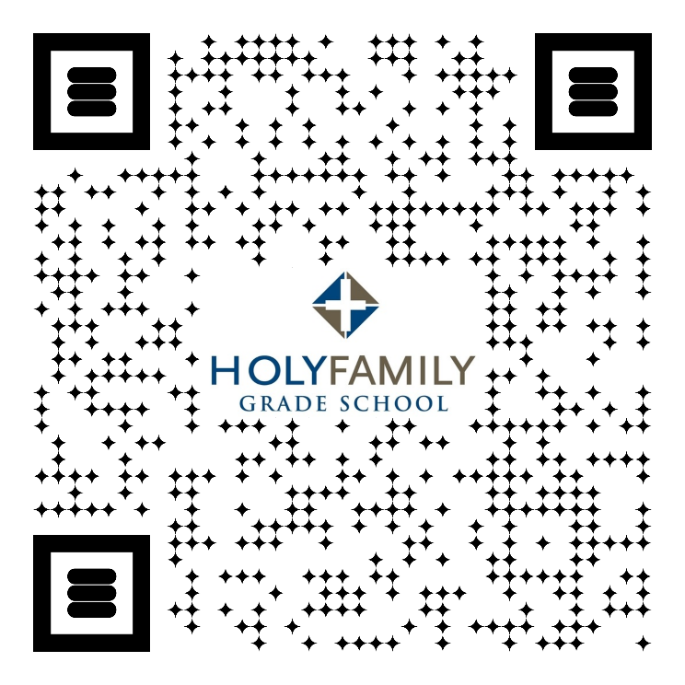
- Scan QR code
- Enter Student’s information
- Complete ✔

